
Lampara Electrical Installation Services
Carlo Abanilla - Sales
Maligaya St. Brgy. Lusacan,Tiaong,Quezon
24 Lanzones St. Brgy Potrero Malabon City Metro Manila
09707834005 lamparaeis@gmail.com
364923009 1975327

Quotation

To,
Ervin Pacheco
Quotation# PV System Quotation-294
Date: September 4, 2026

Dear Sir/Mam,

Thank you for your valuable inquiry. We are pleased to quote as below:

Supply of Materials, Tools, Supervision and Technical skills for the Installation of the PV system.

# | DESCRIPTION | QTY | PRICE | TOTAL
1 | PV System Installation - 6kWp Hybrid Package  *Tier 1 SOLAR 610-630W - 12pcs  *Solis Inverter (S6-EH1P6K-L-PRO/PLUS) 6kW - 1pc  *Pylontech 314AH/16kWh - 1pc | 1  Set | ₱366,500.00 | ₱366,500.00
 |  | GRAND TOTAL |  | ₱366,500.00

We hope you find our offer to be in line with your requirement.

Terms & Conditions:
- 1. General

All quotations provided by Lampara Electrical Installation Services (“the Company”) are subject to these Terms and Conditions. By accepting a quotation, the client (“the Customer”) agrees to be bound by these Terms and Conditions.

- Validity of Quotation

Quotations are valid for 7 days from the date of issue unless otherwise specified. Prices, product availability, and installation timelines may change after this period.

- Scope of Work

The quotation outlines the specific products, materials, and services included. Any additional work, variations, or upgrades requested by the Customer will be subject to additional charges.

- Pricing

All prices are quoted in Philippine Peso (PHP) and include/exclude GST as stated. The Company reserves the right to correct any typographical or calculation errors.
- Deposit and Payment Terms Payment terms are as follows:
  - 50% upon signing or approval of the project.
  - 40% after delivery of the materials.
  - 10% after completion of the installation

- Site Access and Requirements

The Customer must provide safe and reasonable access to the installation site. Any delays caused by restricted access, unsafe conditions, or incomplete site readiness may result in additional charges.

- Permits and Approvals

Unless stated otherwise, the Company will assist in obtaining required permits, approvals, and grid connection applications. Approval timelines are dependent on third-party authorities.

- Product Warranties

The following standard product warranties apply:
  - Solar Panels (610-630W): 10 years product warranty
  - Solis Hybrid Inverter: 5 years product warranty
  - Dyness Lithium Battery: 5 years product warranty
  - Pylontech Lithium Battery: 5 years product warranty

After-Sales Warranty:
  - 1 year accessories warranty
  - 2 year workmanship warranty The Company provides workmanship warranties as specified in the quotation.

- Installation Timeline

Installation dates are estimates only and may be affected by weather conditions, supply delays, or other unforeseen circumstances. The Company will notify the Customer of any expected delays.

- Variations

Any changes to the agreed scope of work must be documented and approved. Variations may affect price and timeline.

- Ownership of Goods

All equipment remains the property of the Company until full payment has been received. The Company reserves the right to remove installed equipment if payment is not made according to the agreed terms.

- System Performance

Performance estimates are based on standard conditions. Actual performance may vary due to shading, weather, usage, and other site-specific factors.

- Liability

The Company is not liable for damages arising from:
  - Improper use or unauthorised modifications
  - Pre-existing site defects
  - Events beyond the Company’s control (weather, grid outages, etc.)

- Cancellation

If the Customer cancels after work has commenced or materials have been ordered, the Customer may be liable for costs incurred.

- Governing Law

These Terms and Conditions are governed by the laws of Republic of the Philippines.

- Acceptance

By accepting the quotation, the Customer acknowledges that they have read, understood, and agreed to these Terms and Conditions.


Payment Instructions
Prepared by:

Carlo Fernan P. Abanilla
Account Name : Lampara Electrical Installation Services Account Number: 005698016190
Bank Name: BDO

For, LAMPARA ELECTRICAL INSTALLATION SERVICES

AUTHORIZED SIGNATURE

Proposed location of Inverter and Battery

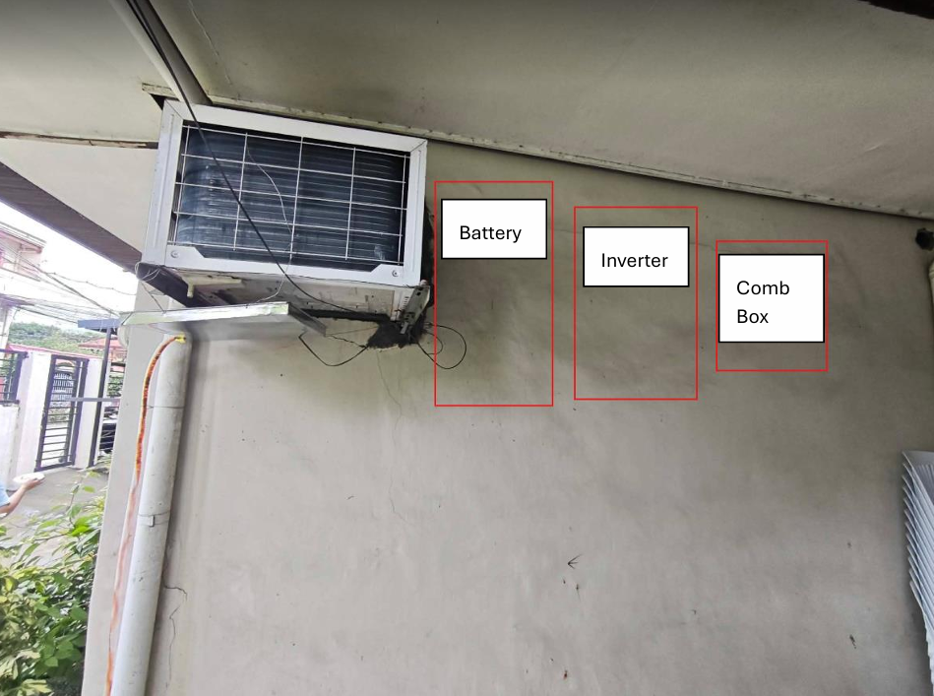
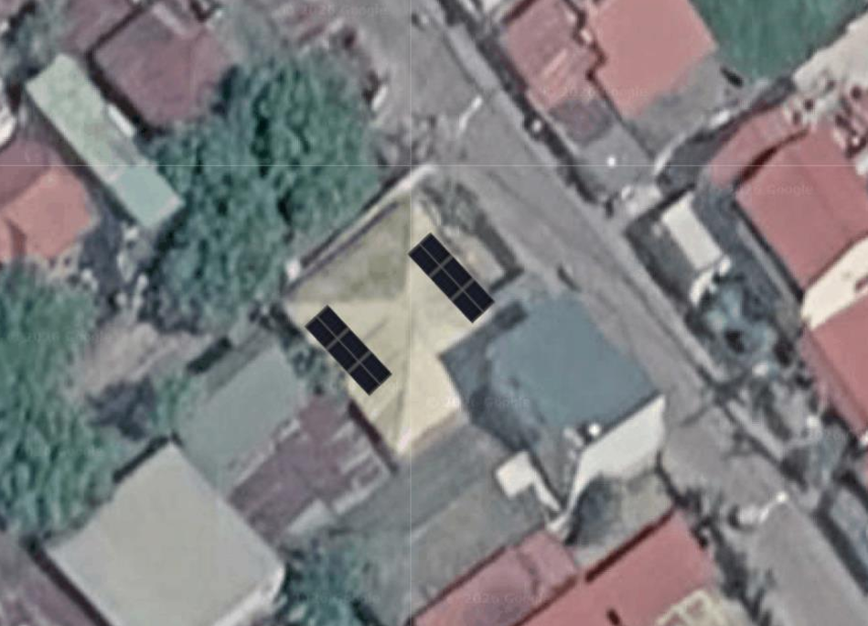
Proposed location of Panels

